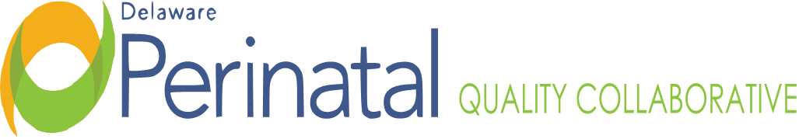
Date: November 18, 2021
Medical Dir.: Garrett Colmorgen, M.D.
Location: Zoom Conference Call

MEMBER ATTENDANCE:
Garrett Colmorgen, MD Karen Kelly, BSN, RN ☑ Julia Paulus, CNM
Bridget Buckaloo, MSN, RNC-OB MSN/MCA K. Starr Lynch, BSN, RN ☑ Anne Pedrick
☑ Christina Bryan ☑ Kathleen McCarthy, CNM, MSN Nancy Petit, MD
☑ Joanna Costa, MD ☑ Christie Miller, MD Kim Petrella MSN, RNC-OB
Mawuna Gardesey Jennifer Novack, MSN, RNC-OB, APN JoEllen Kimmy, DPH
☑ Abha Gupta, MD Susan Noyes, RN, MS Jennifer Pulcinella
☑ David Hack, MD ☑ Rita Nutt Philip Shlossman, MD
☑ Matthew Hoffman, MD David Paul, MD ☑ Megan Williams

FACILITATOR:
Garrett Colmorgen, MD

OTHER STAFF ATTENDANCE:
Lisa Klein, CDRC
Cheryl Scott
Khaleel Hussaini, DPH
Marilee Pinkelton, CPM
Susan Todero, St. Frances
Mary Wise
Cortney Jones

TOPIC | FINDINGS, CONCLUSIONS & RECOMMENDATIONS | ACTIONS | STATUS
I. Call to order | The meeting was called to order by Dr. Colmorgen at 4:01p.m. | No further action. | Resolved
II. Review and approval of Minutes | The minutes from the September 23, 2021, October 28, 2021, meetings were reviewed and approved. | No further action. | Resolved
III. COVID-19 Update | Have lost some staff at hospitals and agencies over vaccine mandates with obvious concern over impact this will have. About ¼ of Bayhealth staff are not vaccinated, yet. COVID numbers are up in Delaware. SF had the highest rate of COVID pregnant patients last week ; two were vaccinated. 10% of children across nation have received vaccine to date. | On-going | On-going
IV. Aspirin Project | Have done training at every hospital and some office visits. Have left messages trying to schedule, please encourage staff to contact Kim for training. Have done the nursing staff meetings at Bayhealth campuses and Tidal Health is scheduled soon. Kim will be speaking to CPM’s in January. | On-going | On-going
V. OBERT Nurses Visit | Tidal Health scheduled for December and Birth Center for January/ February.
VI. SUD/ NOWS Grant Wrap-Up | Grant was originally for one year but extended due to COVID. Have completed 55 new X waivers and 75 providers attended Delaware specific training. Additional work with DSAMH and DHS in support of OBOT site education. Working on hospital, state-wide protocols. Trying to decrease LOS for NOWs babies. At one point it was 17 days. Statewide is down to 16 days with one hospital consistently at 13 days average. Creation of PEDS team to investigate NOWs and other issues.
VII. DPQC Activities | Quarterly report for OBH and SUD grant submitted. Hospital nursing floor visit to LDR and PP and cultivating connections with CPM’s.
VIII. Khaleel Korner | Healthy Soft data from October 2021, comparing hospitals was reviewed. | On-going | On-going
IX. Mawuna’s Minute | As to codification of DPQC, awaiting Board member’s nominations to go through their process to formally appoint the nominees. If you still need to submit your application, please get to Mawuna ASAP so can be submitted to Governor’s office. Working on drafting bylaws of DPQC. Working with AIM to formalize contract.
X. March of Dimes Report Card | Yesterday was world prematurity day. Kim shared highlights from the March of Dimes Report Card. National average was C- and Delaware received D+. For the first time in six years, the U.S. preterm birth rate declined slightly from 10.2% to 10.1%. Yet these rates increased slightly for Black, American Indian and Alaska Native women. Black and American Indian and Alaska Native women are still 60% more likely to give birth preterm compared to White women. The infant mortality rate is slowly declining. The latest data shows a decline from 21,498 babies in 2019 to 20,921 in 2020. However, Black and American Indian and Alaskan native babies are still 2x mas likely as White babies to die before their first birthdays.  Dr. Colmorgen shared that he is still the Delaware Prematurity Chair to MOD but they never reached out to him about this report. MOD supposed to support DPQC, but although asked for assistance, they have not given support Delaware. The disparity is very real in Delaware but the overall data and some comments in the report were incorrect. | On-going | On-going
XI. Breakout Sessions & Reports | The meeting then broke out into the OB and PEDS breakout sessions.  Dr. Paul, PEDS Team: Working to get baseline data. Have received Baythealth’s but awaiting others. Once baseline data is received can start implementing changes  Dr. Colmorgen, OB Team: Khaleel reviewed the data from the Severe Maternal Morbidity (SMM). Report examining data around the Life Course and Social Determinants of Health. The goal is to getter better markers for maternal mortality and to come up with a better treatment approach in the hospitals. One hospital did have a higher SMM ratio than the other hospitals. | On-going | On-going
XII. Attendee Updates | ACOG: Delaware continues to work on policy section which includes Medicare one-year post-partum.  AWOHN: Not much going on due to COVID.  CCHS: Will be getting Pfizer pediatric vaccines soon.  Other: Mary Wise, nurse with DSAHM was introduced as she joined the meeting late. Point person for DSAHM pregnant and postpartum focus. | On-going | On-going
XIII. Adjournment | The chair adjourned the meeting at 5:48pm. | No further action. | Resolved
Minutes prepared by JoEllen Kimmey, DPH

