Program Overview
Delaware’s Title V plans for the coming year are presented below by population domain. These domain “snapshots” convey a brief overview of our goals, progress, and plans for each health area. In some of areas, we are building on years of previous work and partnerships and have very detailed action plans forward. In others, we are forging into new territory and will be spending the time over the course of the five-year grant cycle learning, building expertise, and establishing new relationships.

Population Domain Snapshot: Women’s and Maternal Health
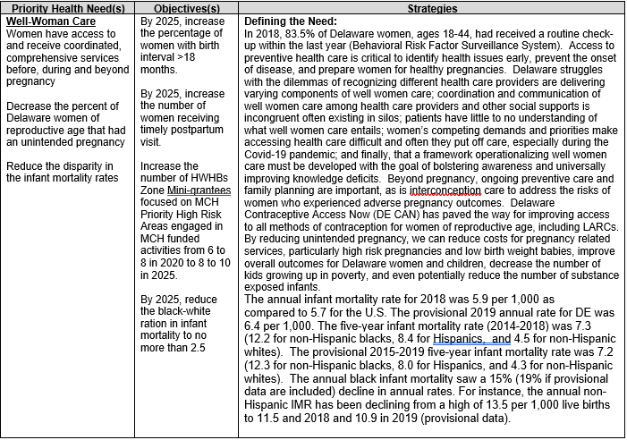
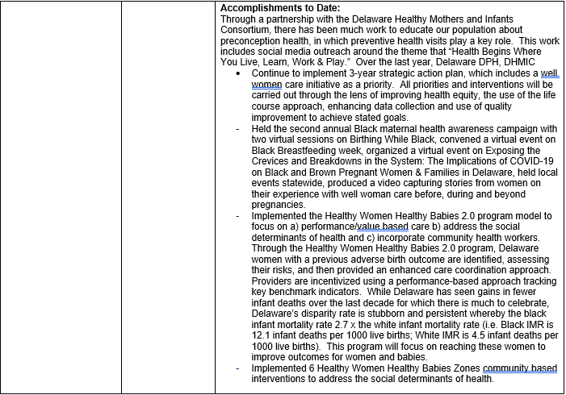
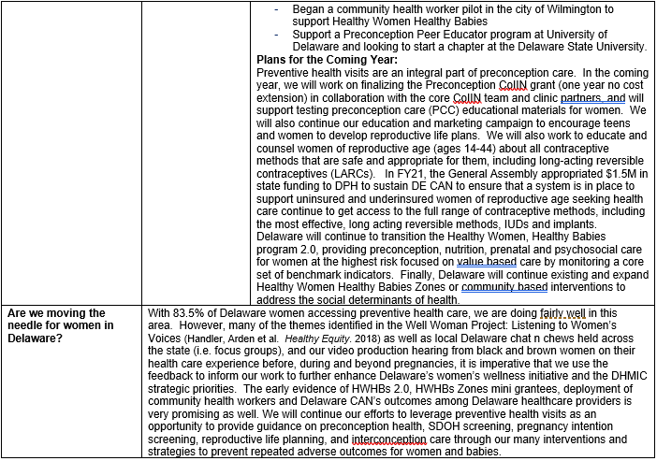

Population Domain Snapshot: Perinatal/Infant Health
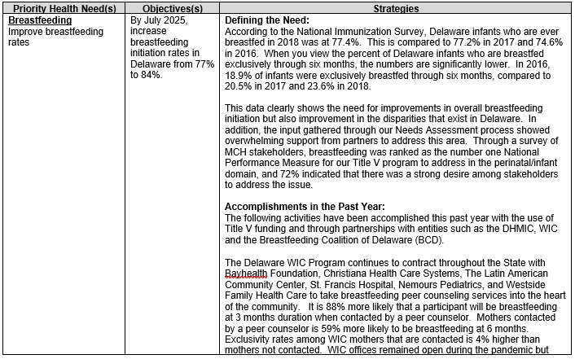
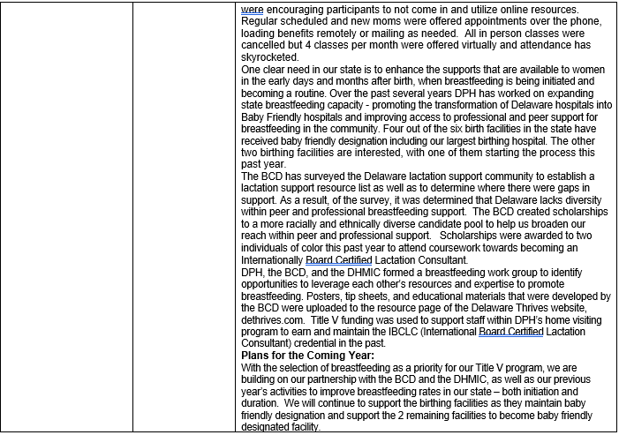
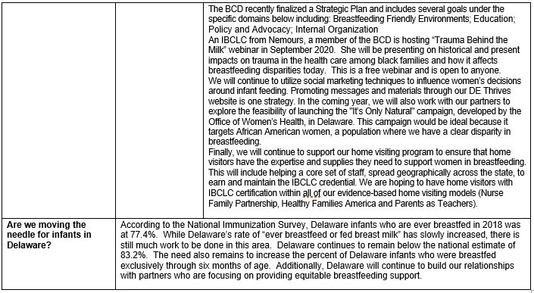
Population Domain Snapshot: Child Health
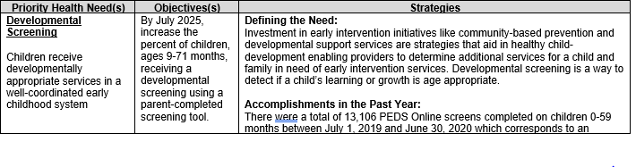
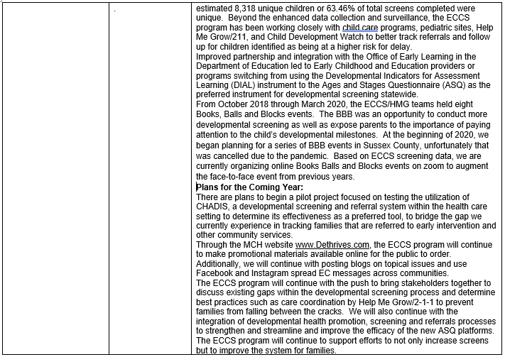
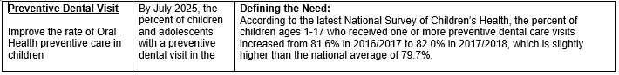
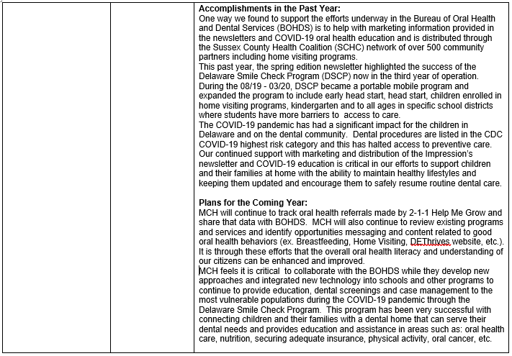
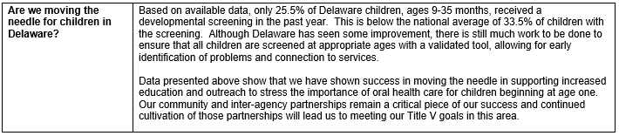
Population Domain Snapshot: Adolescent Health
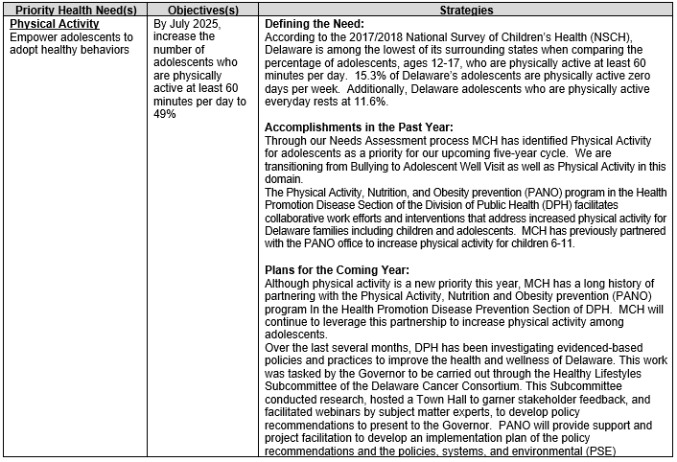
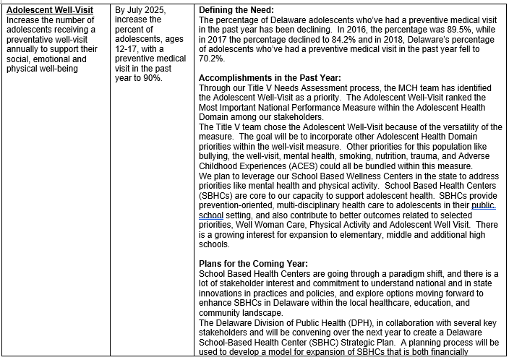
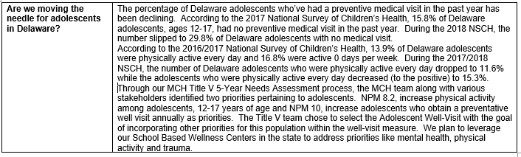
Population Domain Snapshot: Children and Youth with Special Health Care Needs (CYSHCN)
