Track your Cycle Program
By: Anne DeCaire BSN, RN Preconception Nurse Educator
January 2013
Images Used:

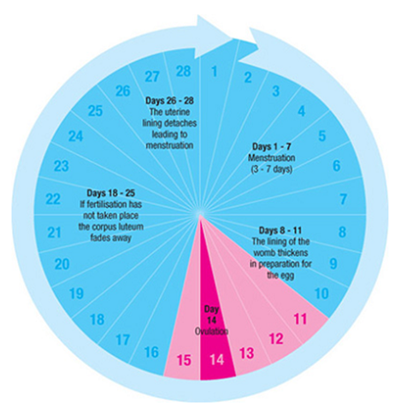

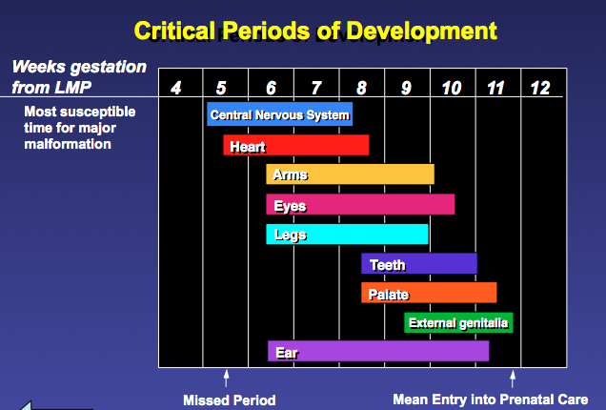

The Four Key Preconception Health Messages:
- 3 Days after your missed Period (See State of DE Adult RLP)…So Track Your Period
- 50% of pregnancies are Unplanned
- 18 Months Birth Spacing message-for best chance of a healthy next pregnancy
- Know your body-empowerment
Tools used:
- Physical Calendar Printed Out
- Suggested Phone Apps for women (and men) to download
- Cycle IQ Quiz – co created with Bridget Buckaloo, MSN,RNC-OB
- Display Board
Engaging with clients:
I introduced myself as an RN and that I am bringing information from the DHMIC and MOD.
I started out being “direct” and asked….”Do you Track your Period?”
Be ready for a variety of responses (depending on age, pregnancy status, birth control methods…)
………………………….

Sample Poster Display:
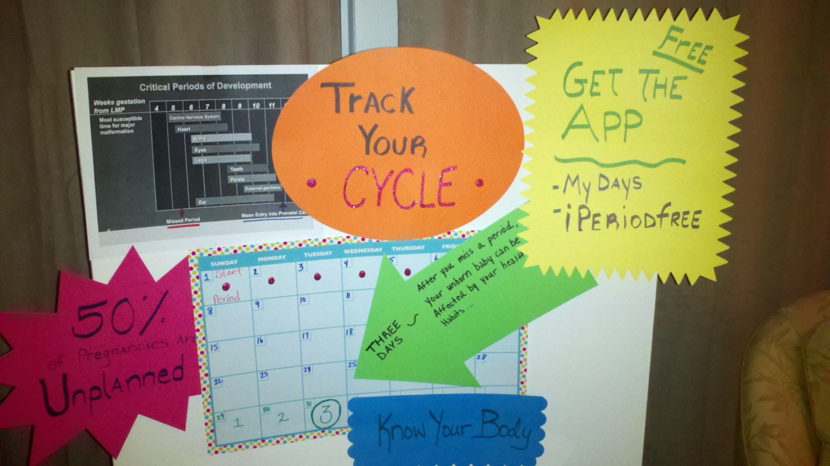
Websites:
- www.healthywomende.com
- Cycle app websites – see what is best/most current – sample them yourself for ease of use
Feel Free to replicate and let me know how it is received by the women and men to whom you present this topic/material.
This is an example of taking the State of DE Reproductive Life Plan messages and making them into a brief, impact board. The hope is to start a trend of women (and men) feeling empowered about their bodies, knowledgeable about their cycle, aware of a missed period and the immediate impact on that developing fetus, and tools to make them successful. Send feedback along to Anne DeCaire at adecaire@marchofdimes.com

