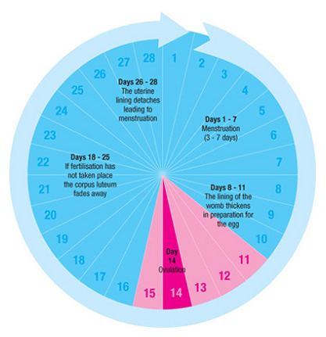
Test Your Cycle IQ

- What is the average menstrual cycle?
  - 21 days
  - 28 days
  - 32-40 days
- Ovulation is:
  - The first day of your period
  - Release of the egg from your ovary
  - The joining of the sperm and the egg
- Most women will ovulate on which day of the cycle?
  - 10 days before the start of the next period
  - 12 days before the start of the next period
  - 14 days before the start of the next period
- Day one of your cycle is:
  - The first day of your period
  - The last day of your period
  - The day after your period ends
- Tracking your period empowers you to know your own body and better understand when and if you have missed your period.
  - True
  - False

-See back for Preconception Health Messaging-

3 Days After You Miss a Period
Your unborn baby can be affected by your health habits
(Track your period and know when you have missed a period)

50 % of All Pregnancies are Unplanned
So plan your pregnancies by taking steps now to be healthy

After having a baby, wait
AT LEAST 18 MONTHS
Before getting pregnant again to maintain the best health for your body and your children

Want to learn more about being a healthy woman? WWW.HealthyWomenDE.com

Want to give the MEN in your life some tips/resources?
WWW.ManUpPlanUp.com

